**DIGITAL SIGNAL PROCESSING LAB**

**Fall 2024, 5th Semester**

**Lab Report 1**



# Submitted by: **Hassan Zaib Jadoon**

Registration Number**: 22PWCSE2144**

Section: **A**

“On my honor, as a student at the University of Engineering and Technology

Peshawar, I have neither given nor received unauthorized assistance on this academic work.”

**Submitted To: Dr. Yasir Saleem Afridi**   
**Department of Computer Systems Engineering**  
**University of Engineering and Technology Peshawar**

**Lab Report: MATLAB Onramp Course**

**Objective:**

### The objective of this lab is to familiarize students with MATLAB through the **MATLAB Onramp** course, enhancing their practical skills in key areas like array manipulation, data import, and plotting. The lab aims to prepare students to apply MATLAB effectively in Digital Signal Processing (DSP) tasks.

**Course Details:**

The **MATLAB Onramp** course is a self-paced, hands-on introduction to MATLAB, covering essential concepts and skills required to effectively use MATLAB in engineering and scientific applications. The course includes interactive exercises that provide immediate feedback and allow students to practice their skills in a practical setting.

**Modules Completed:**

1. **Course Overview:** Provided an introduction to the course, laying the foundation for the tasks ahead.
2. **Commands:** Taught essential commands for performing calculations and creating variables in MATLAB.
3. **MATLAB Desktop and Editor:** Introduced the MATLAB interface and its key features, including the editor for writing and executing scripts.
4. **Vectors and Matrices:** Covered creating, manipulating, and working with vectors and matrices, crucial for data representation.
5. **Array Indexing and Modification:** Explained efficient methods for accessing and modifying specific elements, rows, and columns within arrays.
6. **Array Calculations:** Demonstrated how to perform calculations across entire arrays, streamlining data operations.
7. **Function Calls:** Explored using built-in MATLAB functions, which helps structure solutions for complex problems.
8. **Documentation:** Showed how to use MATLAB’s help and documentation to learn new functions and troubleshoot issues.
9. **Plots:** Provided practical experience with data visualization through plotting functions, essential for analyzing DSP outputs.
10. **Data Import:** Covered importing external data files into MATLAB for further processing and analysis.
11. **Logical Arrays:** Taught the use of logical expressions to extract and work with specific elements of arrays.
12. **Programming:** Introduced conditional statements and control flow to write programs that respond to varying inputs.
13. **Final Project:** Brought together all concepts learned in the course by applying them to a comprehensive project.
14. **Conclusion:** Summarized the key takeaways from the course, reinforcing the learning objectives achieved.

**Modules Completion Picture:**

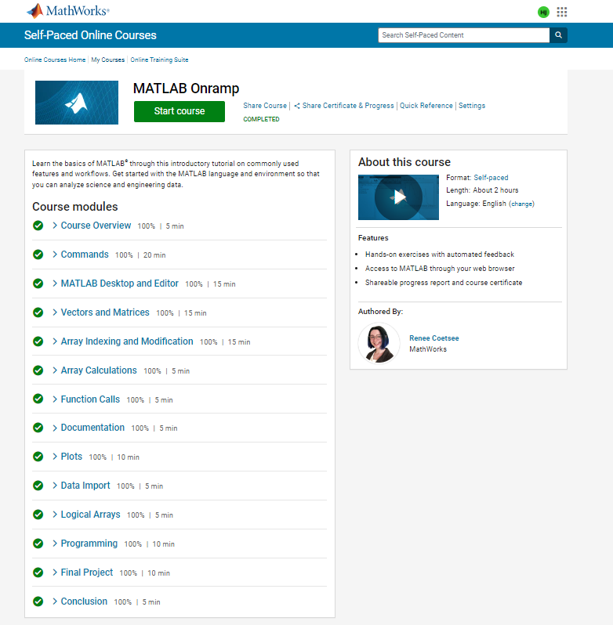

**Course Completion Certificate:  
**

**Course Review**

The **MATLAB Onramp** course provided a thorough revision of MATLAB concepts, and I found it highly practical. Each module allowed me to apply the concepts directly in MATLAB, enhancing my understanding. Completing this course helped me revise my skills and gain confidence in using MATLAB for digital signal processing tasks.

**CSE 402L: Digital Signal Processing**

|  |  |  |  |  |
| --- | --- | --- | --- | --- |
| **Demonstration of Concepts** | **Poor (Does not meet expectation (1))**  The student failed to demonstrate a clear understanding of the assignment concepts | **Fair (Meet Expectation (2-3))**  The student demonstrated a clear understanding of some of the assignment concepts | **Good (Exceeds Expectation (4-5)**  The student demonstrated a clear understanding of the assignment concepts | **Score**  **30%** |
| **Accuracy** | The student completed ( <50%) tasks and provided MATLAB code and/or Simulink models with errors. Outputs shown are not correct in form of graphs (no labels) and/or tables along with incorrect analysis or remarks. | The student completed partial tasks (50% - <90%) with accurate MATLAB code and/or Simulink models. Correct outputs are shown in form of graphs (without labels) and/or tables along with correct analysis or remarks. | The student completed all required tasks (90%-100%) with accurate MATLAB code and/or Simulink models. Correct outputs are shown in form of labeled graphs and/or tables along with correct analysis or remarks. | **30%** |
| **Following Directions** | The student clearly failed to follow the verbal and written instructions to successfully complete the lab | The student failed to follow the some of the verbal and written instructions to successfully complete all requirements of the lab | The student followed the verbal and written instructions to successfully complete requirements of the lab | **20%** |
| **Time Utilization** | The student failed to complete even part of the lab in the allotted amount of time | The student failed to complete the entire lab in the allotted amount of time | The student completed the lab in its entirety in the allotted amount of time | **20%** |